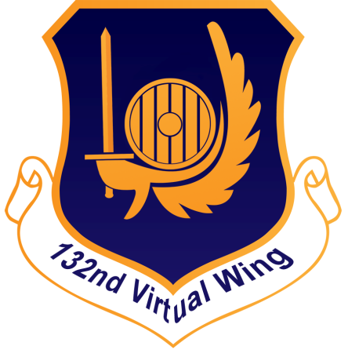

Training Manual

388th Fighter Squadron

Training Manual

132nd Virtual Wing

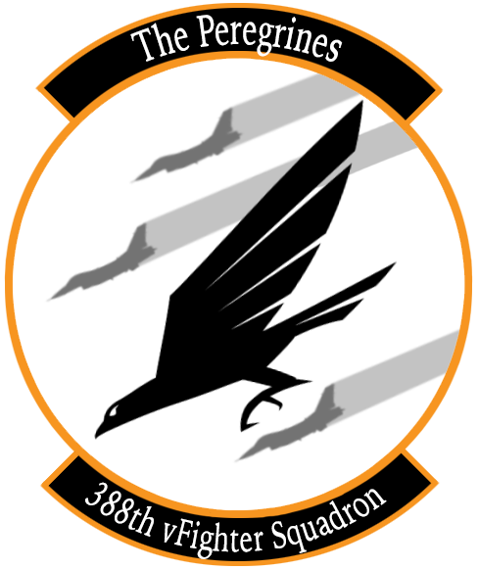

[www.132virtualwing.org](http://www.132virtualwing.org/)

This work is licensed under a[Creative Commons Attribution-ShareAlike 3.0 Unported License](http://creativecommons.org/licenses/by-sa/3.0/).

Training Manual

|  |  |
| --- | --- |
| Applies to: | 388th Fighter Squadron |
| Type: | Training Manual |
| Version: | 0.2 |
| Published date: | 28.09.2019 |
| Document responsible: | Trollef |
| summary of changes: | Initial Draft |
| rEFERENCES: |  |

Contents

**1.** **INTRODUCTION** 4

2. **INITIAL QUALIFICATION TRAINING**(IQT) 5

2.1 BAS-04: **AIR TO AIR REFUELLING** (SQ) 5

2.3 BAS-05: **PRECISION FLIGHT** (SQ) 11

2.5 COM-01: **THE 132ND WAY OF FLYING** (IP) 12

3. MISSION QUALIFICATION TRAINING(MQT) 13

3.1 TAC-01: **FORMATION AND TURNS** (IP) 13

3.2 TAC-02: **DEFENSIVE SYSTEMS AND MANOEUVRES** (SQ) 18

3.3 TAC-03: **NIGHT OPERATIONS** (SQ) 18

3.4 TAC-04: **AWACS COMMUNICATIONS** (SQ) 18

3.5 SAT-01: **HIGH AND MEDIUM ALTITUDE DELIVERIES** (SQ) 18

3.6 SAT-02: **LOW ALTITUDE DELIVERIES** (SQ) 18

3.7 ACT-01: **ACM 1v1 WVR MANOEUVRING** (IP) 18

3.8 ACT-02: **BVR ENGAGEMENTS AND MUTUAL SUPPORT** (IP) 18

3.9 TAC-05: **MISSION QUALIFICATION TRAINING CHECKOUT** (IP) 18

4. **CONTINUATION TRAINING** (CT) 19

4.1 ACT-03: **DCA CAP** (SQ) 19

4.2 ACT-04: **OCA SWEEP**(SQ) 19

4.3 ACT-05: **OCA ESCORT** (SQ) 19

4.4 SAT-03: **SAT FLIGHT LEAD**(SQ) 19

4.5 SAT-04: **ARMED RECONNAISSANCE**(SQ) 19

4.6 ACT-06: **DCA INTERCEPT**(SQ) 19

4.7 SAT-05: **CLOSE AIR SUPPORT**(IP- CAS INSTRUCTOR) 19

4.8 SAT-06: **SCAR**(SQ) 19

5. **UPGRADES** (UGT) 20

5.1 SAT-07: **FLUG 2-SHIP: OPPOSED SAT** (IP) 20

5.2 ACT-07: **FLUG 4-SHIP: DCA CAP** (IP) 20

5.3 SAT-08: **FLUG 4-SHIP: OPPOSED SAT** (IP) 20

5.4 ACT-08: **MISSION COMMANDER UPGRADE: DCA CAP** (IP) 20

5.5 SAT-09: **MISSION COMMANDER UPGRADE: SAT AI** (IP) 20

5.6 SAT-10: **FORWARD AIR CONTROLLER (AIRBORNE)** (IP- CAS INSTRUCTOR) 20

6. **CONVERSION TO TYPE TRAINING** (CTT) 21

7. TO BE ADDED LATER 21

**8.** **TERMS** 22

# **INTRODUCTION**

**Scope**: The Training Manual is a supplement to the 132ndwing Standard Operating Procedures (SOP), Tactics, Techniques and Procedures (TTP) and other documents such as the range orders and airfield charts, which are common to all squadrons and air frames, and the 388th SOP and kneeboard pack, which is specific to the 388th and the F-16C.

The Training Manual provides information, context and detail that are not found in the above documents, such as *how* to actually perform a tactical turn or set up the datalink correctly. It follows the Training Programme step by step, and you as a pilot should read and refer to it as you go through the programme.

This should also save you from having to research a lot of material on your own, as we have already compiled this document with information about how to perform most tasks in the jet, and within the flight, all within the context of the squadron’s standard operating procedures.

Note that this document does not describe every track in the training programme. Weapons, avionics and similar that are not specific to the 132nd should be learned from other sources, such as the flight manual provided by Eagle Dynamics.

The Training Manual also sets out the *expectations* of the 132nd Virtual Wing to a pilot in thePeregrines, by providing a clear baseline for what we expect you to be able to do at each point in the training programme, and of course afterwards as a mission qualified pilot.

We hope this document will be some help in preparing you to fly with the 388th “Peregrines” Virtual Fighter Squadron.

**Pilot responsibility**: Use common sense

* SOPs describe standardised *procedures* for routine operations.
* TTP’s describe *techniques* that can be used in different situations.

Neither are substitutes for common sense and judgment, nor they represent the sum of all experience. You’ll make a few new experiences on your own, or find yourself in a situation the SOP or TTP’s do not describe. It is the pilot's responsibility to fly the aircraft safely and effectively in all circumstances, as required to accomplish the overall mission.

Weapon, sensor and avionics mechanics and operational descriptions are not covered here, nor is air and ground vehicle recognition. I.e. we won’t tell you how a radar works or what a BMP looks like, but will have an expectation that you find this hobby interesting enough to learn new things.

**Recommended changes**: Improvements and recommended changes to this SOP should be stated to the parties nominated in the Document Responsible section above.

# **INITIAL QUALIFICATION TRAINING**(IQT)

## BAS-04: **AIR TO AIR REFUELLING** (SQ)

Air- to- air refuelling (AAR) is a critical skill to master. It should be conducted regularly by any pilot, outside of the regular hosted training- and combat events if need be, in order to maintain proficiency. Familiarisation with the procedures outlined below is essential in order to be able to conduct safe and efficient aerial refuelling operations in a multiplayer environment.

The following explains how AAR is conducted in the 132nd Virtual Wing. There are no squadron- specific SOP’s for AAR, because several aircraft types use the same tanker types. This means that in a mission, you can find yourself on the tanker with any other aircraft capable of refuelling from a boom (as opposed to the drogue used by the F/A-18 and F-14), such as the F-15C and A-10C. With the A-10C in particular, different tankers are usually available due to the difference in preferred refuelling airspeed and altitude between the types.

Note that AAR begins on the ground, with mission preparation. Fuel is a very scarce resource in the F-16, and fuel considerations will be an important factor in any mission planning. As a minimum, the pilot should familiarise himself with the tanker information provided through the Mission Data Card (MDC): Callsign, TACAN, radio frequency and altitude, and also the location of the tanker track.

You will most often take fuel from a KC-135.

TIP: When planning a mission, it is a good idea to place a waypoint in the middle of the tanker track in order to provide you with real-time information about your ability to refuel from your current location in the most optimal manner using the ICP CRUS TOS and RNG subpages.

Tankers will typically fly the following “contract":

* + 40- 50nm racetrack pattern
  + Mach 0.6 (around 300KCAS)
  + Turns at X degrees of bank

Before refuelling, MASTER ARM shall be set to OFF and lights set according to SOP or Flight Lead’s instruction.

**AAR IN FIVE STAGES:**

1. **RENDEVOUZ**

*Communications and deconfliction*

When the Flight Lead makes the decision to head for the tanker, he will coordinate with the controlling agency and push the flight to the tanker frequency at an appropriate distance from the tanker, normally about 10- 15nm.

Note that the tankers normally operate on VHF in order to enable the flights to monitor the AWACS nets on UHF while on the tanker. This means that you will use the tanker frequency as your internal frequency. There may be other flights on the same frequency, so keep use brevity and keep chatter to a minimum.

Flight Lead will check in on the tanker frequency, typically with the following:

* Number and type of aircraft (“Viper is two times F-16…)
* Position (“inbound TEXACO from the North, FL190, 20 miles”)
* Lowest fuel state in the flight (“fuel six eight”, meaning 6800lbs)

This is an informative call to other flights. If there is another flight inbound, the flight with the least fuel refuels first unless the others mission is more time critical. The flight leads will coordinate deconfliction.

If there is another flight already on the tanker, you’ll hear something like: “Copy Viper, this is SPECTER1, two times chicks in tow.” (Other flights that are in formation with the tanker (stages 2 through 5 below) are referred to as “chicks in tow”.)

Call out any positions you are in, and any intentions to shift positions, for example:

* “Two established left observation.”
* “One moving pre-contact.”

*The rendezvous:*

Because the tanker is anchored in a racetrack, the fighter has to come to the tanker. This means there’s a bit of geometry involved. For **low-aspectrendezvous**(i.e. if you’re chasing the tanker), it is relatively straightforward:

* Configure the jet according to the AAR checklist.
* Approach at the tanker’s designated altitude *minus* 1000ft.
* Gradually reduce overtake.

This means that if the tanker is at FL200, you approach at FL190 until you are visual with the tankerand ready to join the left observation position or, if cleared to do so, the pre-contact position.

The 388th contract speed is 350KCAS or M0.8, whichever is lower, so you will have about 50 knots overtake on the tanker. Reduce this gradually as you approach, but also be careful not to spend excessive amounts of time crawling up on the tanker. You can use the radar closure rate in STT mode and TACAN readout to judge your rate of closure.

For **high- aspect rendezvous**, we use the “fighter turn-on” technique.This is a real-life technique designed to provide a standardised and effective method for joining on the tanker:

* Turn towards the tanker when it is at 35° relative bearing and 15nm distance.
* Turn using the standard 30° of bank and 350KCAS energy sustaining turn. (See chapter 3.1. for a cockpit reference for 35°.)
* The tanker should be at 4.5nm at 7° relative bearing, and you should exit the turn 2.5nm in trail of the tanker.
* At this point, you’re on a low-aspect rendezvous as described above.
* For a more aggressive rendezvous, start the turn earlier, but only after passing the tanker.
* You can switch to DGFT or MSL OVRD to quickly re-gain radar lock if it is lost during the turn.
* Open the refuelling door 3-5 minutes before joining on the tanker, in order to let the tanks depressurise fully before taking fuel. At the same time, set your DED repeater on the HUD and bring up the BINGO page to see your current fuel on the HUD while refuelling.
* Make sure you are stable and stick natural when opening the refuelling door, because this will switch the flight control system to landing gains mode with increased sensitivity to assist with AAR.
* Note that centreline tanks do not top up completely even if properly depressurised.

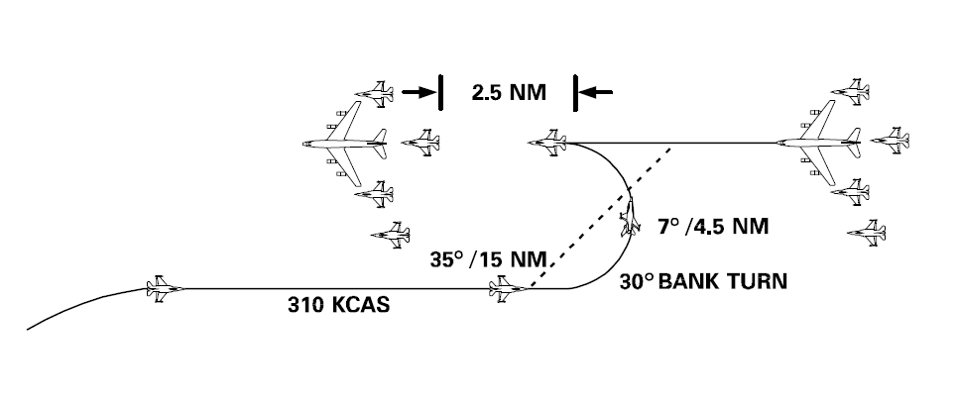

Figure : The Fighter Turn On

1. **LEFT OBSERVATION**

The 132nd Wing uses a “left to right” refuel pattern, where flights anchor to the tanker on the left side, refuels in sequence and then anchors on the right side of the tanker when done. Formally, this is called the “observation position”, however, we prefer to use left and right observation to avoid any confusion.

The aircraft with the least fuel will as a rule refuel first. In many cases, this will be the wingman, because he typically burns more fuel in order to re-join and maintain formation with the flight lead. If there is no other flight on the tanker, the aircraft with the least fuel will in many cases move straight into the pre-contact position in order to save time, however, the flight lead should keep the wingman in formation until established in the left observation position if and as required for deconfliction, particularly with inexperienced wingmen. Regardless:

* Only move to left observation or pre-contact when cleared to do so by flight lead.
* Once in the left observation position, all subsequent positions are flown referencing the tanker (not other aircraft in the flight). This is in order to allow the receiving aircraft freedom of movement around the pre- contact position.
* If there’s more than one aircraft in the left observation (or right), only the innermost aircraft references the tanker; other aircraft reference the next aircraft.
* Be careful to maintain a constant distance, particularly if there are other aircraft in the observation position.
* Align the tanker’s wingtip with the tanker’s cockpit window.
* Maintain at least one wingspan’s distance.

Note that if you’re training, the instructor pilot may fly aft of the proper position in order to be in a better position to observe.

1. **PRE-CONTACT**

Pre-contact is a position slight aft and centre of the contact position, where you stabilise the jet for contact.

* Reduce throttle slightly to move the aircraft back from the left observation, then flow gently into the pre-contact position:
* The pre-contact position should be slightly below the boom, centred, and about the length of your jet aft.
* Stabilise speed and attitude, and give the “ready pre-contact” radio call.
* When cleared by the boom operator, ease forward to the contact position.

At this point, you’ll be looking through the HUD. It may be tempting to use the HUD elements or HUD frame as a reference because of the lack of a canopy bow in the F-16, particularly if you’re used to a canopy bow for positional referencing. Our advice however, is to fly off the actual tanker *just like you did in the left observation*, instead of suddenly starting to use the HUD as a reference just because you switched position.

For example, if there is a sidewind, there will be an offset between your gun cross and flight path marker unless you’ve remembered to enable the drift cut-off, making it difficult to use HUD elements as constant or absolute references. Keep it simple, use Mk.1 eyeball and practise. The Viper is actually quite easy to refuel compared to many other jets: the boom keeps you stable, the throttle is responsive and you have great visibility.

1. **CONTACT**

The contact position is where the boom connects to your jet, and you take fuel.

* When cleared by the boom operator, flow forward slowly using gentle throttle input (1-2% should be enough).
* Either reference the yellow centre line and let the boom pass directly over you, or offset slight to the left and let it pass slightly high and left.*
* Once past the boom, follow the director lights to maintain the correct position.
* Monitor the fuel quantity to disconnect at the pre-briefed value if not topping off 100%, and to anticipate the disconnect if taking a full fuel load.

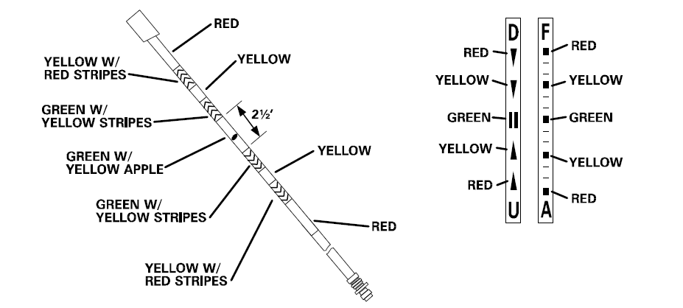

Figure : Boom and director lights, KC-10

The difficult part is of course to maintain the correct position:

* Make only small input corrections,
* In one axis (up/down, left/right, forward/aft) at the time, and
* Wait to see the effect of each correction.

The three points above are very important, and should be done as a continuous process. By only correcting one thing at a time and waiting to see the effect, you effectively prevent pilot- induced oscillations, where you compound the behaviour you want to negate by essentially piling corrections on top of each other. This is a common mistake.

* The boom moves very suddenly as you approach for contact. Do not chase the boom, fly off the director lights.
* Mentally preface the director lights with the word “GO”. I.e. GO aft, GO down.
* Continuously cross- reference the director lights with the tanker itself: in time, you will develop a “mental image” and feel for your ideal position.
* Some pilots like to “wiggle” the throttle, that is, making continuous but very small back-and forth corrections instead of trying to match the tanker speed precisely.
* If you start seeing oscillations or struggle with anything, slide back to pre-contact, re-stabilise and try again from a stabilised position.
* Note that if you have a disconnect but is not directed back to the pre-contact, the boom operator may take some time before he is able to re-connect. All you can do is to verify that the AR/NWS light says “RDY” and maintain formation.
* If you move out of position in one direction, *both* director light columns may change. For example, if you move too far down you may get a “Go forward” light as well as “Go up”, because you’ve extended the boom as well as its angle by going down.
* The director lights will only give you up/down and forward/ aft directives, not left/ right. Use the yellow centre line marker on the belly of the tanker.
* Upon disconnecting, the aircraft may tend to go forward due to the lack of back-pressure from the boom. You can anticipate this by monitoring the fuel quantity.

* These are two techniques with different advantages and disadvantages. Find the one you’re most comfortable with:

* Using the “centre line” technique, it is easier to maintain lateral position, but a bit more difficult to establish the correct vertical position after passing the boom than the “left pass” technique, because your aircraft will be lower in order to allow the boom to pass the canopy bubble;
* Using the “left pass” technique, horizontal position is easier because you have less distance to move up after passing the boom, however, you will be off- centre and need to slide into position to the right.

BREAKAWAY

“Breakaway” is an emergency directive from the tanker to you to break away immediately to avoid a dangerous situation. Immediately reduce throttle (use speed brakes if necessary) and altitude to clear the tanker, but do not break out of the pre-contact position’s altitude block.

Aircraft in the observation positions maintains formation if it is safe to do so.

1. **RIGHT OBSERVATION**

Right observation is the mirror image of left observation:

* When disconnected, flow gently aft into the pre-contact position.
* Stabilise and close the refuelling door.
* Flow into the first open slot.
* Follow flight lead’s directive to leave the observation position, re-join formation and exit the tanker track.

Note that when you close the refuelling door, the flight control system will revert back from landing gains to normal operations. It is important to be stabilised with the stick in neutral when you do, because this will cause an increase in control input thresholds and thereby increased control surface movement. Doing so while manoeuvring will cause a slight “jump”, which can be hazardous in tight formations.

## BAS-05: **PRECISION FLIGHT** (SQ)

Precision flight means the ability to fly the jet within very precise flight parameters over time, in order to facilitate the “contract”, formation flight and tactical turns. All these are described in the MQT- part of the training programme, but because all these depend on precision flight, it is placed in the IQT part of the syllabus.

Precision flight in practice means the ability to maintain a set, constant airspeed, at a given altitude and heading, in a correct position from flight lead, and to perform “energy- sustaining turns”.

Energy- sustaining turns are designed to sustain the energy of the jet (and the flight) by turning at a rate that maintains the airspeed. Usually, this will be the contact airspeed of 450KCAS/M0.7.This in contrast to for example a max G turn (which will deplete your airspeed), or a turn at a set bank angle like 30° (which can be performed with different speeds across the turn).

To perform an energy- sustaining turn, enter a level turn and pull as much G as you can while maintaining the airspeed.

We do this so as to maintain the formation integrity, particularly when in a combat formation. For example, if the distance between your jet and flight lead’s is supposed to be 1.5nm, and the formation is to perform a tactical turn to a new heading and exit the turn with the same 1.5nm distance, the only way to do that effectively is if both are turning at the same speed (and therefore the same turn rate.)

The other variables of precision flight, are speed and altitude, and finally position. You should be able to maintain a constant airspeed of ±5 knots of the prescribed speed, and ±25 feet of the prescribed altitude. (And of course at the prescribed heading, but heading is easy to maintain.)

Correct position is relative to another jet, such as flight lead or a tanker. The “left observation” position on the tanker is a good example of precision flight, with speed, altitude and relative position from the tanker (the tanker’s wingtip aligned with the tanker’s cockpit window) all being within very fine parameters.

You will also be expected to fly precision flight in tactical formations with more distance between the jets. We often use “yardstick”, i.e. TACAN distance, to maintain correct distance in such cases, which will typically be the Line Abreast or Trail formations.

The best way to train precision flight on your own, is to practice aerial refuelling, as it contains all elements of precision flight. Once you’re topped off, fly some energy- sustaining turns and try flying Trail or Line Abreast of the tanker (see the Formations chapter).

## COM-01: **THE 132ND WAY OF FLYING** (IP)

The objective of COM-01 is to familiarize the pilot with the procedures of flying multiplayer within the 132nd such as communication with ATC and AWACS, and procedures around the airfield and controlled airspace.

##### Explain the difference between FL, WM, supporting and engaged.

##### Sign-up

In order to sign-up for an event, find the event on the 132nd event page, once on the page for a specific event, manuever at the bottom of the page, and click on sign up, as shown below in yellow.

You will then be listed in the pilot roster, and the event host can assign you to a flight.

If you have any restrictions or request (for example regarding timings, specific aircraft, booking of a range or airspace etc), you write that in the commschatter for the event.

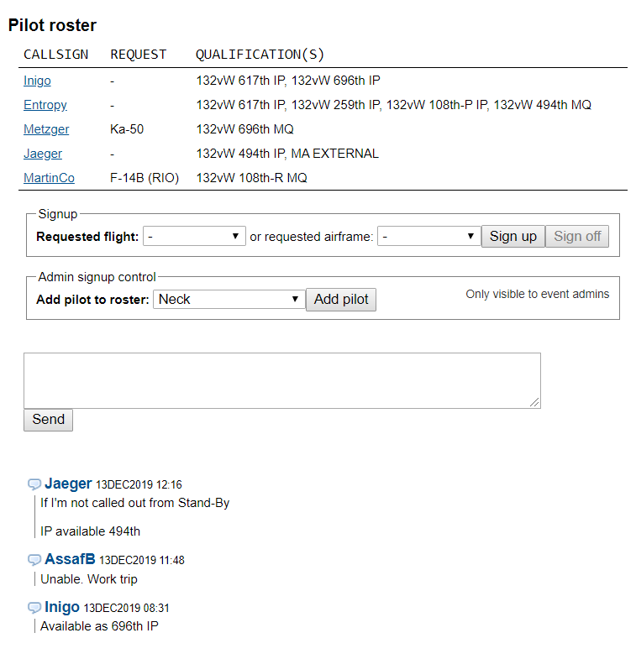

##### Event commschatter

The events commschatter is located at the bottom of the event page, as seen in the yellow circle below. Here information regarding the event in general is posted.



##### Flight Commschatter / Info

Once you are assigned to a flight, and know your tasking, you can go into the flight page, where you find information about frequencies assigned to the flight, the flights own commschatter and where to fill the flightplan for the flight. First you need to find your flight, and click on the flights mission number, as shown in yellow below.

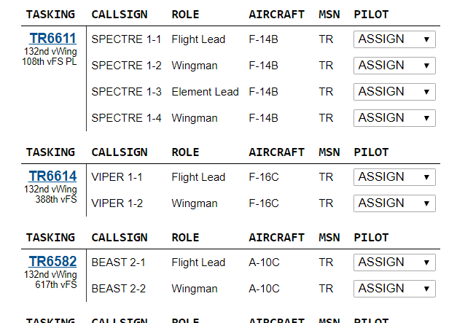

Inside the flights page, you can share information with your other flight members. The Flight Lead should and normally will publish the Mission Data Card as a link in the commschatter (Tasking chatter) in yellow below.

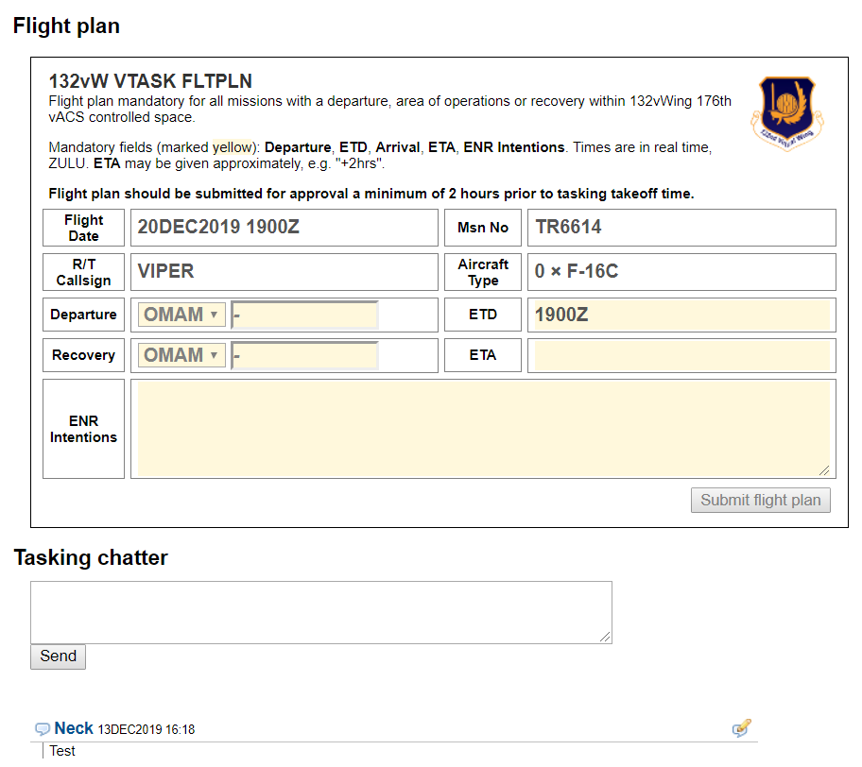

##### Flightplan

In the flight page, there is also where the Flight Lead must fill in the flightplan for the flight. This information is used by controlling agencies and for situational awareness for other flights. Fill out departure and recovery airfield. Fill out the planned departure time (ETD=Estimated Time of Departure) and the planned recovery time (ETA=Estimated Time of Arrival). Also fill in the intentions for the flight. For example, what type of departure, what is the route and taskings, and the planned recovery. In addition you can also add relevant information for controllers, such as loadouts, timings, frequencies you will be monitoring, who you will be working together with etc.

All information in the flightplan is what is a planned, and deviations might occur in flight, and that is normal and not a problem.



##### Communication the 132nd Way

Radio communication is vital to ensure coordination and mission success

**Radio communication will have one of three purposes:**

* Ask for clearance(s)
* Give instructions
* Receive Instructions

**Note:**

VHF/UHF Radios are one-way communications only. We want efficient delivery of information by using as few words, in the shortest time possible in order to get our message across while freeing up the radios as much as possible.

* **During a flight, you (or FL) will talk to THREE or FOUR agencies...**
  + *GROUND (GND) (Not always used)*
  + TOWER (TWR)
  + CONTROL (CTRL)
  + AWACS (DARKSTAR/MAGIC/CRYSTAL/OVERLORD)
* **…and request THREE clearances**
  + GND: Taxi Clearance
  + TWR: Departure Clearance
  + TWR: Landing Clearance

##### Altitude and flight levels

##### Authentication

AET-100

TAT-100

RAMROD

# MISSION QUALIFICATION TRAINING(MQT)

## TAC-01: **FORMATION AND TURNS** (IP)

The objective of TAC-01 is to familiarize the pilot with the formations and turns used in the 388th Peregrines. Formations and turns are used tactically, and achieves several important things for the flight, such as mutual support, visual coverage, massing of firepower and a common point of reference. Before the actual turns and formations are discussed however, there are some basics that should be explained. This chapter will be structured as follows:

* Fundamentals
* Cockpit references
* The contract
* Formations
* Turns

### SOME FUNDAMENTALS

Maintaining **mutual support** is a key objective of formations and turns. By “mutual support”, we mean the ability of each flight member to support the other by being in formation, enabling visual lookout coverage of the wingman’s six o’clock and blind spots (underneath and behind the aircraft) and the ability to respond to threats. This can be for example calling out incoming ground fire on the radio, or engaging an enemy fighter with weapons. I.e. good mutual support maximizes the entire flight’s offensive posture, situational awareness and thereby its ability to achieve its mission objectives by providing:

* Positional awareness of flight members and other units around the formation.
* Early detection and positional awareness of threats.
* Support decision making, particularly whether to attack or disengage.

Mutual support is part of the “contract” discussed later.

**Visual lookout** is a critical part of mutual support, and is an absolute priority for all flight members. The formations are designed to provide the best possible visual coverage, and to deny an enemy an unseen entry into the formation. This of course presupposes that someone is actually looking. For this reason, we use visual scan sectors, very much like how lead and wingman have different radar scan responsibilities: see the contracts- section below.

The wingman or supporting fighter have a particular responsibility for maintaining a constant visual scan around the formation, because the flight lead or engaged fighter is often “heads down” working with a sensor. Although “heads down” should be called out, it is very often the case that the lead pilot is preoccupied with sensors to a greater degree than the wingman. Have this in mind whenever you fly in a supporting position. (From experience, it is the wingman who first spots other aircraft.)

Flying the F-16 in a complex environment requires continuous attention to numerous tasks and responsibilities. However, *you can only ever do one thing at the time*. Get into the habit of mentally assigning yourself single tasks at the time, as the time and situation allows. For example:

* High altitude, “low workload”: *Full visual scan🡪 Flight instruments🡪 Radar🡪HIS🡪repeat.*
* Low level, “high workload”: *Limited visual scan🡪 Flight instruments🡪repeat.*

### COCKPIT REFERENCES

The following are useful references when flying formations, or for quickly calling out references to any observation:

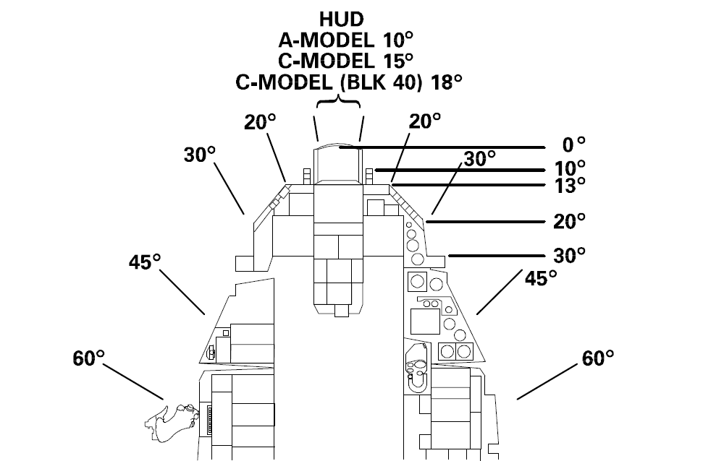

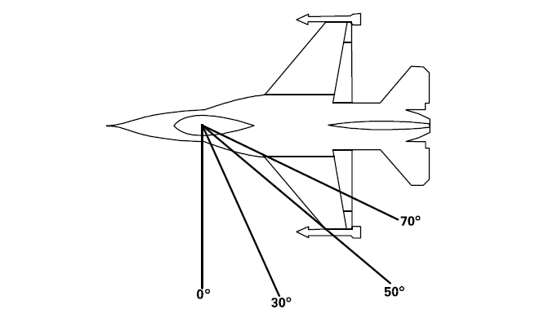

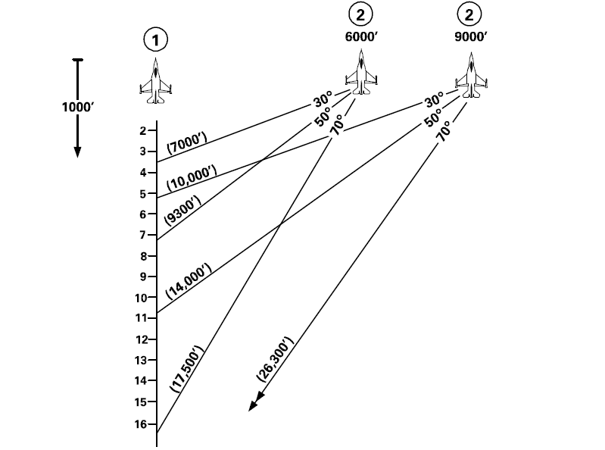

### FORMATION RESPONSIBILITIES

* **FLIGHT LEAD:** Primary decision maker, flight- external communications, navigation and radar lookout, and engaged fighter if practical. Mutual support for wingman.
* **WINGMAN:** Maintain formation and deconfliction, visual lookout and mutual support for Flight Lead. Navigation, radar and other situational awareness as other responsibilities allow.
* **ELEMENT LEAD:** Support Flight Lead. Secondary decision maker, flight- external communications, navigation and radar lookout, and secondary engaged fighter if practical. Mutual support for wingman and the rest of the flight.
* **ELEMENT WINGMAN:** Maintain formation and deconfliction, visual lookout and mutual support for Element Lead.Navigation, radar and other situational awareness as other responsibilities allow.

### VISUAL LOOKOUT

The visual lookout pattern applies to all flight members as their responsibilities allow, and is designed to monitor the aerospace around the aircraft and the flight in prioritised order. (This means that if you for example are down at low level and manoeuvring, and padlocked on the flight lead, you may only be able to scan sector 1 and occasionally 2.)

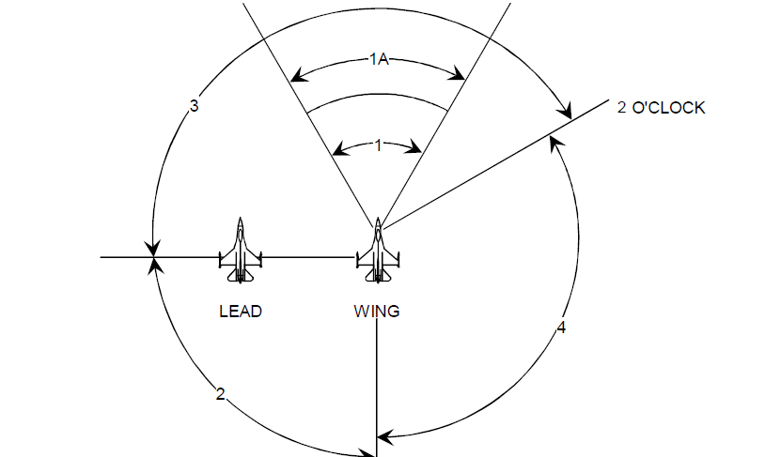

* **SECTOR 1:** This sector is called NEAR ROCKS, and is anything that may constitute an immediate threat.
* **SECTOR 1A:** This sector is called FAR ROCKS, and is anything that would affect future manoeuvring.
* **SECTOR 2:** This sector is the six o’clock position. Notice in the image above how the wingman scans the flight lead’s six, and although not indicated, flight lead’s sector 2 is the wingman’s six.

Sectors 1 and 2 make up the basic lookout cross-check, which should be checked on each lookout cycle:

***“NEAR ROCKS, FAR ROCKS, CHECK SIX.”***

* **SECTOR 3:** This sector is *inside* the flight, and *ahead* of the flight’s 3/9 line.
* **SECTOR 4:**This sector is *outside* the flight and *aheadand behind* the 3/9 line. Sector 4 completes the full 360 degree of the visual lookout.

### THE CONTRACT

The “contract” is a set of pre-defined parameters and responsibilities we use to standardise and “automate” certain tasks in the flight, such as standard departure line-ups and cruise speeds. Key parts of the current contract are always provided in the 388th Kneeboard Pack/ In-flight Guide document.

The contract consists of the following elements:

1. **Flight Parameters during different stages of flight and turns**

Specified in the In-flight Guide.

1. **Formation Responsibilities**

See above.

1. **Visual Lookout**

See above.

1. **Radar Scan**

Specified in the In-flight Guide.

I.e., by having a contract, we do not need to pre-brief things like re-join- and cruise speeds, radar scan responsibilities, landing patterns or that all tactical turns are conducted as energy sustaining turns.

If nothing else is briefed, follow the contract.

Now, with the basics covered, it is time for formations and turns:

### FORMATIONS

#### FORMATION DEPARTURE

#### Rolling departure

#### Trail departure

Conditions

#### FINGERTIP

#### LINE ABREAST

Explain how integrated with radar scan sectors

#### TRAIL

#### WEDGE

#### FIGHTING WING

### TURNS

#### CHECK TURN

#### HOOK TURN

#### CROSS TURN

#### TACTICAL TURNS

#### PITCH BACK

#### SLICE BACK

## TAC-02: **DEFENSIVE SYSTEMS AND MANOEUVRES** (SQ)

## TAC-03: **NIGHT OPERATIONS** (SQ)

## TAC-04: **AWACS COMMUNICATIONS** (SQ)

## SAT-01: **HIGH AND MEDIUM ALTITUDE DELIVERIES** (SQ)

## SAT-02: **LOW ALTITUDE DELIVERIES** (SQ)

## ACT-01: **ACM 1v1 WVR MANOEUVRING** (IP)

## ACT-02: **BVR ENGAGEMENTS AND MUTUAL SUPPORT** (IP)

## TAC-05: **MISSION QUALIFICATION TRAINING CHECKOUT** (IP)

# **CONTINUATION TRAINING** (CT)

## ACT-03: **DCA CAP** (SQ)

## ACT-04: **OCA SWEEP**(SQ)

## ACT-05: **OCA ESCORT** (SQ)

## SAT-03: **SAT FLIGHT LEAD**(SQ)

## SAT-04: **ARMED RECONNAISSANCE**(SQ)

## ACT-06: **DCA INTERCEPT**(SQ)

## SAT-05: **CLOSE AIR SUPPORT**(IP- CAS INSTRUCTOR)

## SAT-06: **SCAR**(SQ)

# **UPGRADES** (UGT)

## SAT-07: **FLUG 2-SHIP: OPPOSED SAT** (IP)

## ACT-07: **FLUG 4-SHIP: DCA CAP** (IP)

## SAT-08: **FLUG 4-SHIP: OPPOSED SAT** (IP)

## ACT-08: **MISSION COMMANDER UPGRADE: DCA CAP** (IP)

## SAT-09: **MISSION COMMANDER UPGRADE: SAT AI** (IP)

## SAT-10: **FORWARD AIR CONTROLLER (AIRBORNE)** (IP- CAS INSTRUCTOR)

# **CONVERSION TO TYPE TRAINING** (CTT)

CTT offers a type conversion arc from the F/A-18C Hornet to the F-16C Viper, and is only available for 494th MQT- pilots with 75+ flight hours logged with the squadron.

The 388th SOP and training programme is derived from the 494th, and both jets have a great deal of SOP- and type similarity, as well as with regard to mission types. Therefore, the CTT is designed to offer a basic conversion, focusing primarily on avionics that are specific to the F-16C.

CTT consists of:

* BAS-05 (SQ)
* AVI-03 (SQ)
* AVI-04 (SQ)
* AVI-05 (SQ)
* TAC-05 (IP)

After passing CTT, the pilot achieves MQT- status in the 388th.

# TO BE ADDED LATER

* IP
* AGGRESSOR

# **TERMS**

|  |  |  |
| --- | --- | --- |
| Term | meaning |  |
|  |  |  |
|  |  |  |
|  |  |  |
| ACT | Air Combat Tactics |  |
| AI | Air Interdiction |  |
| AR | Armed Reconnaissance |  |
| BVR | Beyond Visual Range |  |
| CAP | Combat Air Patrol |  |
| DCA | Defensive Counter Air |  |
| FLUG | Flight Lead Upgrade |  |
| OCA | Offensive Counter Air |  |
| SAT | Surface Attack Tactics |  |
| SCAR |  |  |
| WVR | Within Visual Range |  |
| mdc | Mission Data Card | A standardised card with all critical mission information, such as frequencies and flightplan. |
| kcas | Knots Calibrated Air Speed |  |
| 3/9 line |  |  |